H.T No
Regulations:
A20

Sreenidhi Institute of Science and Technology
(An Autonomous Institution)
Code No: 8K301 Date: 13-Feb-2024 (FN)

B.Tech II-Year I- Semester External Examination, Jan/Feb-2024 (Supplementary)
SOLID MECHANICS(CIVIL)

Time: 3 Hours Max.Marks:70

Note: a) No additional answer sheets will be provided.
b) All sub-parts of a question must be answered at one place only, otherwise it will not be valued.
c) Missing data can be assumed suitably.
Bloom's Cognitive Levels of Learning (BCLL)

Remember | L1 | Apply | L3 | Evaluate | L5
Understand | L2 | Analyze | L4 | Create | L6

Part - A Max.Marks:20

Answer all QUESTIONS.

 |  | BCLL | CO(s) | Marks
1 | What are tensile and compressive forces? Give examples | L1 | CO1 | [2M]
2 | Differentiate sagging and hogging bending moments | L1 | CO2 | [2M]
3 | Define the terms neutral axis and section modulus | L1 | CO3 | [2M]
4 | What is the limitation of the double integration method? | L1 | CO4 | [2M]
5 | What is mohr’s circle? | L1 | CO5 | [2M]
6 | what is shear strain energy theory | L1 | CO6 | [2M]
7 | Define longitudinal strain and lateral strain? | L1 | CO1 | [2M]
8 | Draw the variation of Bending stress across the depth of a beam of rectangular cross section | L2 | CO3 | [2M]
9 | Define deflection and slope of a beam. | L1 | CO5 | [2M]
10 | Write a short note on point of contraflexure . | L1 | CO1 | [2M]

Part – B Max.Marks:50
ANSWER ANY FIVE QUESTIONS. EACH QUESTION CARRIES 10 MARKS.

 |  |  | BCLL | CO(s) | Marks
11. | a) | A bar of varying section is loaded as shown in figure.Determine the total Elongation. If E=2X10⁵ N/mm²  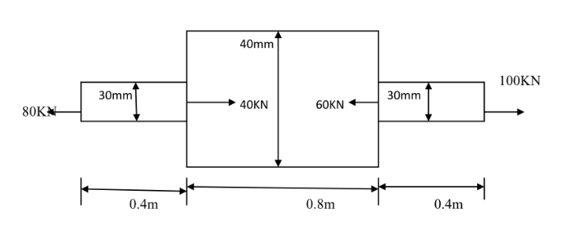 | L3 | CO1 | [5M]
 | b) | Write the Relation between three Elastic Moduli | L2 | CO1 | [5M]
12. |  | A cantilever of length 1.8m carrying a point loads of 20KN, 15KN and 10 KN at 0.3m,0.9m and 1.8m from fixed end and a uniformly distributed load of 8KN/m over 0.6m from the free end. Draw S.F. and B.M diagrams. | L3 | CO2 | [10M]
13. |  | Derive the relationship M/I = σ/y = E/R. | L3 | CO3 | [10M]
14. |  | What is moment area method? Explain the two Mohr’s theorems, as applicable to the slope and deflection of a beam. | L3 | CO4 | [10M]
15. |  | An elemental cube is subjected to tensile stresses of 30 N/mm² and 10N/mm² acting on two mutually perpendicular planes and a shear stress of 10N/mm² on these planes. Draw the mohr’s circle and determine the magnitudes and direction of principal stresses and also the greatest shear stress | L3 | CO5 | [10M]
16. |  | Prove that the shear stress in case of rectangular section is given as τ_{max}=1.5τ_{avg} | L3 | CO6 | [10M]
17. | a) | Derive a relation for change in length of a tapered bar hanging freely under its own weight. | L2 | CO1 | [4M]
 | b) | Derive the relation between shear force and bending moment in beam section | L2 | CO2 | [3M]
 | c) | Derive the section modulus equation for rectangular section | L2 | CO3 | [3M]
18. | a) | Explain the concept of conjugate beam method. | L2 | CO4 | [4M]
 | b) | Define the term obliquity and how it is determined | L2 | CO5 | [3M]
 | c) | Write a short note on maximum principal stress theory | L2 | CO6 | [3M]
-- 00 -- 00 –

